AI-LAB TEST-03

Set E12
Q1:
Scenario: In the Education sector, a company faces a challenge related to web frontend development.
Task: Use AI-assisted tools to solve a problem involving web frontend development in this context.
Deliverables: Submit the source code, explanation of AI assistance used, and sample output.
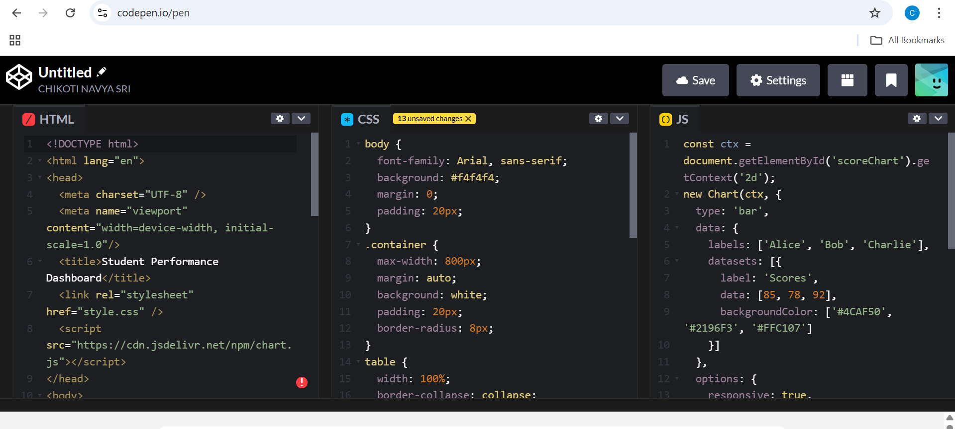
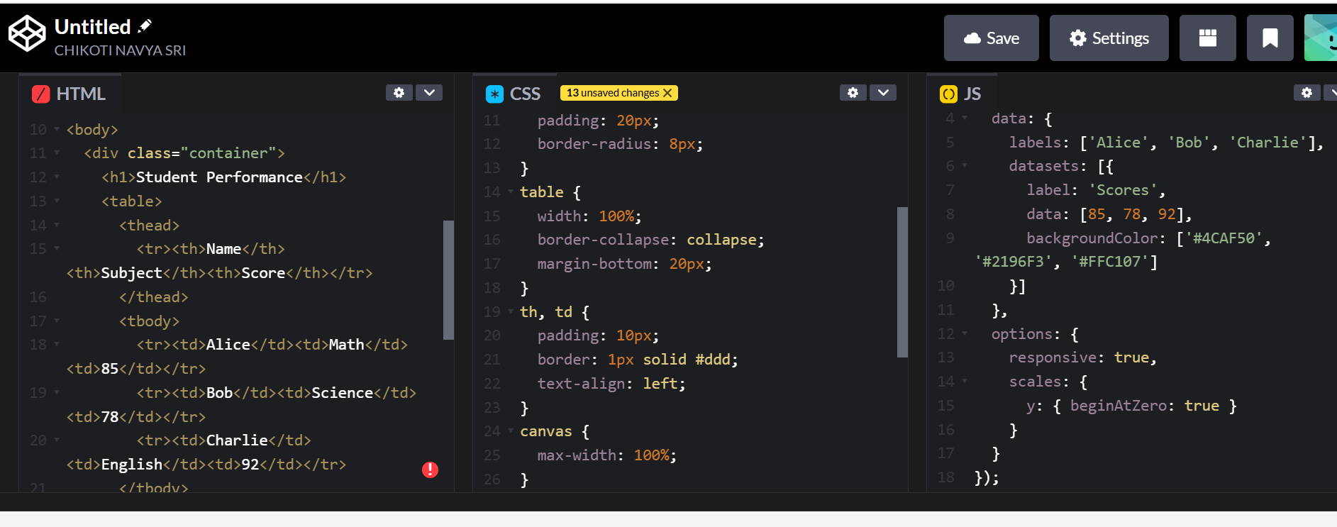
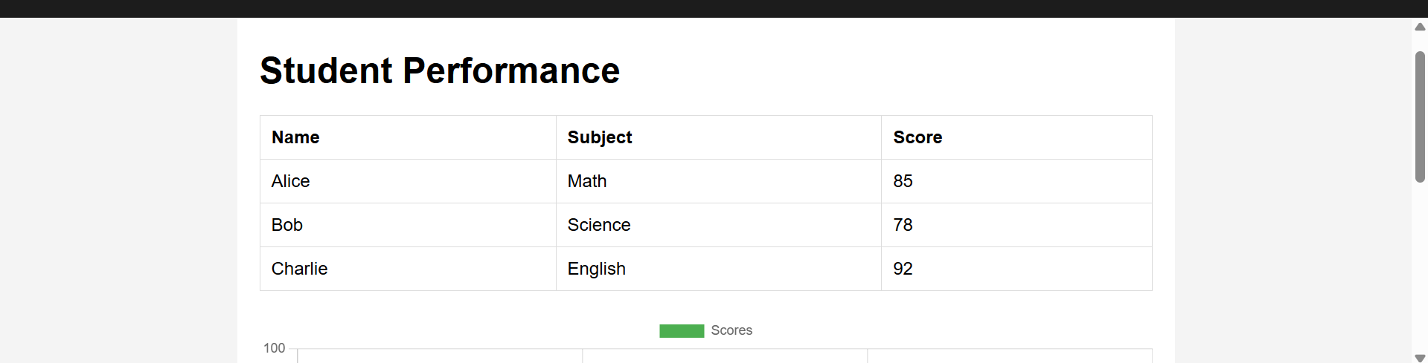
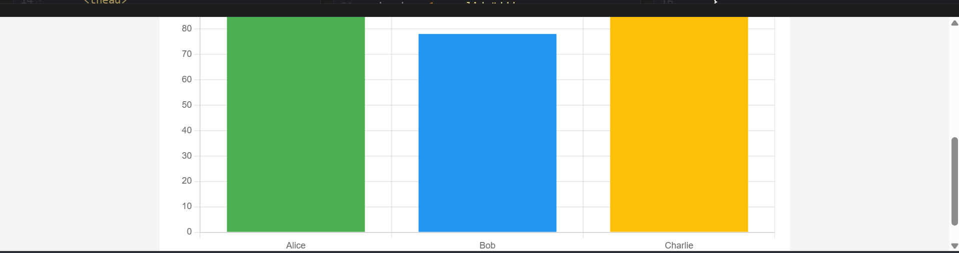

02.
Scenario: In the Retail sector, a company faces a challenge related to algorithms with ai assistance.
Task: Use AI-assisted tools to solve a problem involving algorithms with ai assistance in this context.
Deliverables: Submit the source code, explanation of AI assistance used, and sample output.
